

**INSTITUTE FOR ADVANCED COMPUTING AND SOFTWARE DEVELOPMENT, AKURDI, PUNE**

**Credit Card Fraud Detection Using Logistic Regression And XGBoost**

PG-DBDA Mar 2024

Submitted By:

Group No: 10

Roll No. Name.

243530 Navin Chokhat

243551 Sidharth Naik

**Mr. Abhijit Nagargoje Mr. Rohit Puranik**

Project Guide Centre Coordinator

## ABSTRACT

The purpose of this project is to detect the fraudulent transactions made by credit cards by using machine learning techniques, to stop fraudsters from the unauthorized usage of customers’ accounts. The increase in credit card fraud is overgrowing worldwide, which is the reason actions should be taken to stop fraudsters. Putting a limit on those actions would positively impact the customers as their money would be recovered and retrieved back into their accounts and they wouldn’t be charged for items or services that were not purchased by them, which is the project's main goal.

Detection of the fraudulent transactions will be made by using the machine learning technique Logistic Regression and XG Boost this model will be used on a credit card transaction dataset. Also tuning the hyperparameter for efficient accuracy.

The application of a credit card fraud detection system spans multiple areas, including real-time transaction monitoring, customer notifications, risk management, compliance, and ongoing model improvement. These applications help financial institutions reduce fraud, protect customers, and maintain regulatory compliance, ultimately leading to a safer and more secure payment ecosystem.

## ACKNOWLEDGEMENT

I take this occasion to thank God, almighty for blessing us with his grace and taking our endeavor toa successful culmination. I extend my sincere and heartfelt thanks to our esteemed guide, Mr. Narendra Pawar for providing me with the right guidance and advice at the crucial juncture sand for showing me the right way. I extend my sincere thanks to our respected Centre Co-Ordinator Mr. Rohit Puranik, for allowing us to use the facilities available. I would like to thank the other faculty members also, at this occasion. Last but not the least, I would like to thank my friends and family for the support and encouragement they have given me during the course of our work.

Navin Vinodrao Chokhat (240341225029)

Sidharth Vassudeva Naik

(240341225049)

IACSD Credit card fraud detection using logistic regression and XGBoost

**Table of Contents**

|  |  |  |
| --- | --- | --- |
| **Sr.No** | **Description** | **Page No.** |
| 1 | Introduction | 1 |
| 2 | Purpose of the Project | 2 |
| 3 | Project Scope | 3 |
| 4 | Aims & Objectives | 4 |
| 5 | Requirements Specification | 5 |
| 6 | Workflow of the Project | 6 |
| 7 | Data Preprocessing | 7 |
| 8 | Exploration and Visualization | 9-10 |
| 9 | Balancing the Dataset | 11 |
| 10 | Feature Selection & Engineering | 12 |
| 11 | Model Building | 13 |
| 12 | Model Tuning | 14-17 |
| 13 | Model Evaluation | 18-19 |
| 14 | References | 20 |
| 15 | Conclusion | 21 |
| 16 | Future Scope | 22 |

## INTRODUCTION

Credit card fraud has seen a significant rise, reflecting broader trends in global credit card usage. In 2023, credit card fraud was the most reported type of identity theft, accounting for 48% of all reports to the Federal Trade Commission (FTC) in the United States. The FTC received over 416,000 credit card fraud reports that year, and total losses due to fraud exceeded $10 billion, marking a sharp increase from 2022. Additionally, the number of data compromises reached an all-time high, with over 3,200 reported cases in 2023.

Credit card fraud has become a significant challenge for financial institutions and consumers. With the exponential growth in online transactions, fraudsters have developed increasingly sophisticated methods to exploit vulnerabilities in payment systems. As a result, detecting and preventing fraudulent transactions has become a critical area of focus. This document outlines a comprehensive approach to credit card fraud detection using Logistic Regression, a widely used statistical method for binary classification problems.

Building on this foundation, XGBoost, a powerful ensemble learning technique, offers enhanced performance and accuracy by combining multiple decision trees. It addresses the limitations of traditional models like Logistic Regression by capturing complex patterns in data, making it a robust choice for detecting intricate fraud schemes in real time.

### Purpose of the Project

### 

We propose a Machine learning model to detect fraudulent credit card activities in online financial transactions. Analyzing fake transactions manually is impracticable due to the vast amounts of data and its complexity. However, adequately given informative features, could make it possible using Machine Learning. This hypothesis will be explored in the project.

To classify fraudulent and legitimate credit card transactions by supervised learning Algorithms such as Logistic Regression and XG Boost. To help us to get awareness about the fraudulent and without loss of any financially.

**Scope**

In this proposed project we designed a protocol or a model to detect fraud activity in credit card transactions. This system is capable of providing most of the essential features required to detect fraudulent and legitimate transactions. As technology changes, it becomes difficult to track the Modeling and pattern of fraudulent transactions. With the rise of machine learning, artificial intelligence, and other relevant fields of information technology, it becomes feasible to automate this process and to save some of the intensive amount of labour that is put into detecting credit card fraud.

**Aims & Objectives**

The primary goal of this project is to develop a sophisticated credit card fraud detection system capable of accurately identifying fraudulent transactions in real time. The project will involve the extraction and engineering of key features from large-scale financial transaction datasets to enhance the system's ability to detect fraud. Machine learning models, including Logistic Regression and XGBoost, will be meticulously trained and fine-tuned to classify transactions and identify anomalies that may indicate fraudulent activity. These models will undergo rigorous evaluation, with a focus on metrics such as accuracy, recall, and F1-score. The top-performing model will be selected for integration into the final system, ensuring a robust and reliable solution for real-time fraud detection. This system will empower financial institutions to effectively detect and prevent fraudulent transactions, adding a crucial layer of security in today's increasingly digital financial landscape.

**Requirements Specification**

1.1 **Hardware Requirement:**

* + - 500 GB hard drive (Minimum requirement)
    - 8 GB RAM (Minimum requirement)
    - PC x64-bit CPU

1.2 **Software Requirement:**

* + - Windows/Mac/Linux
    - Python-3.9.1
    - VS Code/Anaconda/Google collab
    - Python Extension for VS Code
    - Libraries:
      * Numpy 1.18.2
      * Pandas 1.2.1
      * Matplotlib 3.3.3

Scikit-learn 0.24.1

**Workflow of the Project**

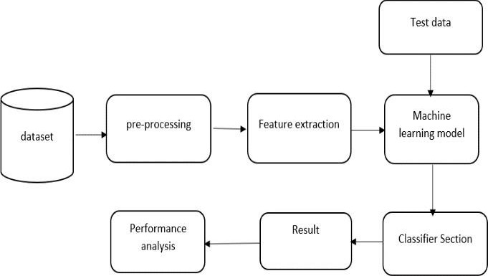

**Data Preprocessing**

After choosing the most suited dataset the preparation phase begins, the preparation of the dataset includes selecting the wanted attributes or variables, cleaning it by excluding Null rows, deleting duplicated variables, treating outliers if necessary, in addition to transforming data types to the wanted type, data merging can be performed as well where two or more attributes get merged. All those alterations lead to the desired result which is to make the data ready to be modeled.

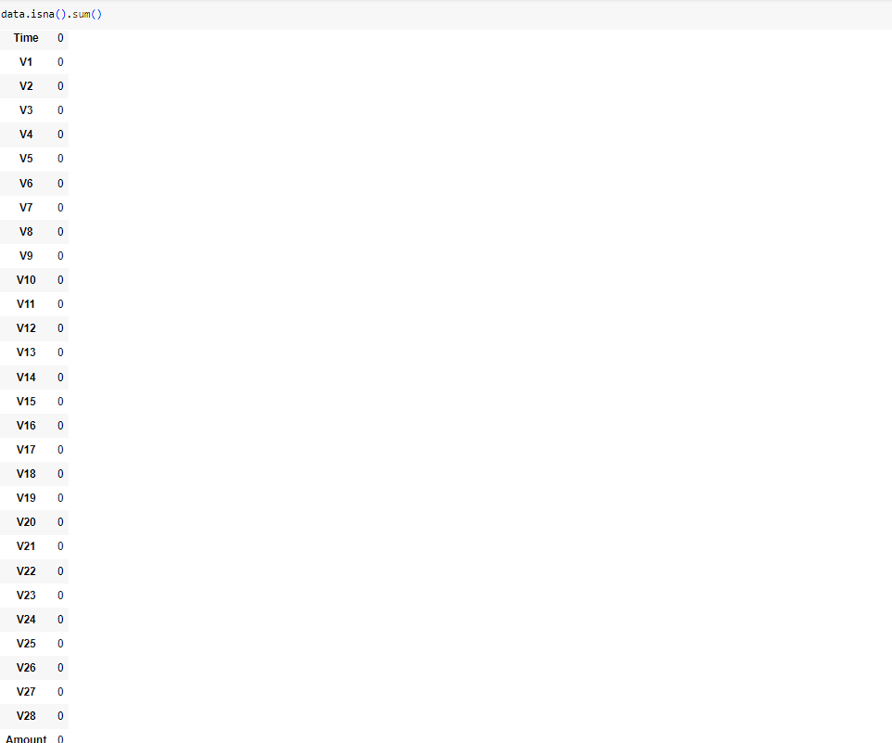

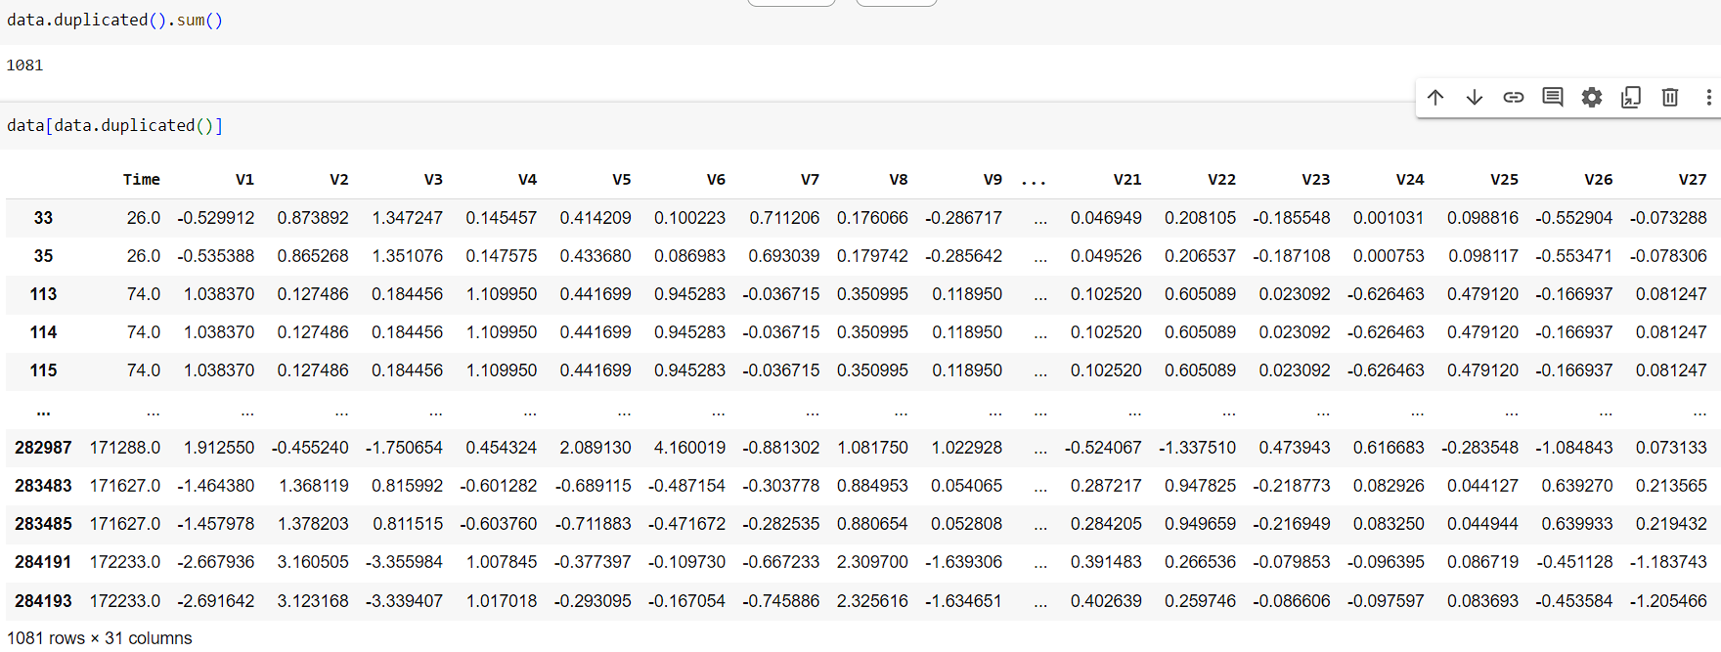

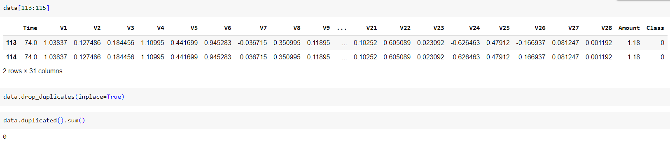

**Exploration and Visualization**

Exploring the dataset through descriptive statistics and visualizations helps in understanding the distribution of data, identifying outliers, and spotting potential anomalies that could impact the model’s performance.

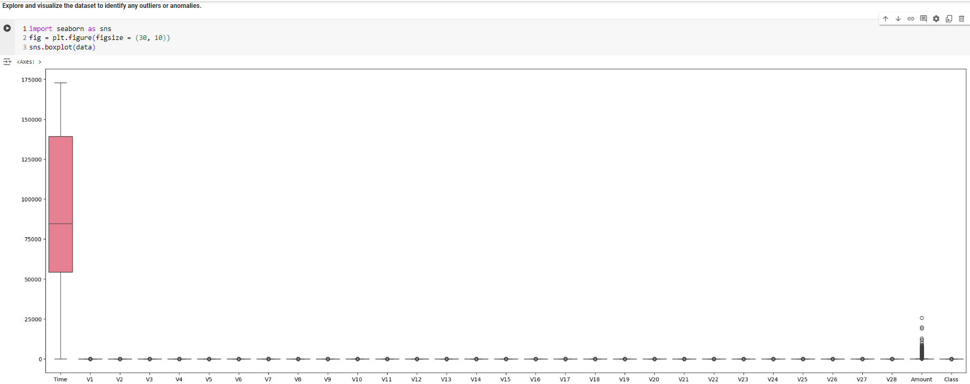

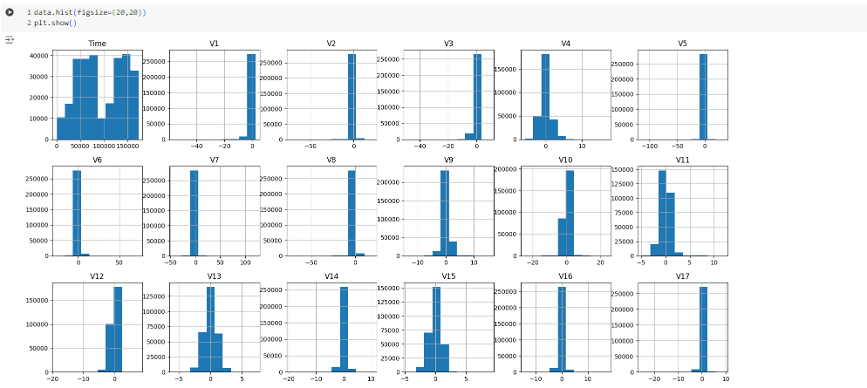

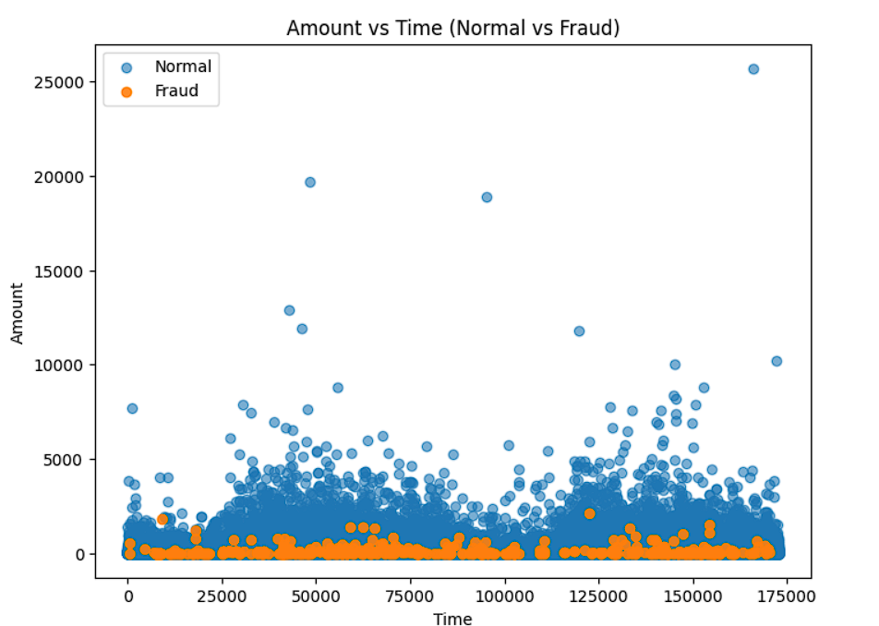

Pie chart of Unbalance Class Bar chart of Unbalance Class

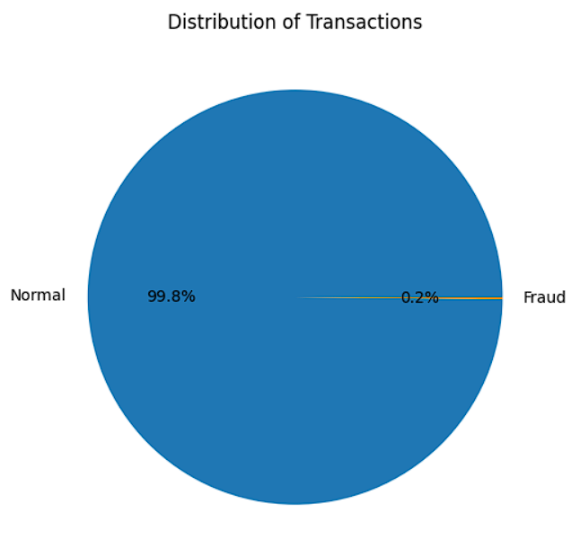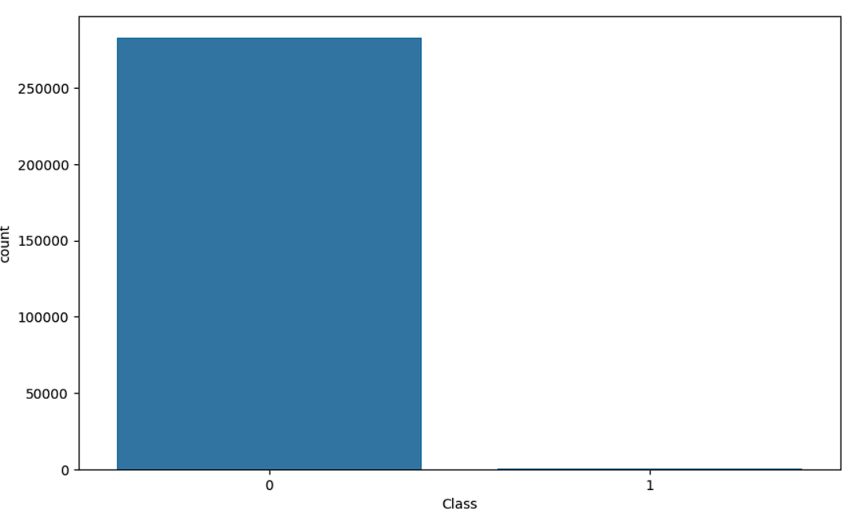

**Balancing the Dataset**

Credit card fraud detection typically involves imbalanced datasets, where fraudulent transactions are far fewer than legitimate ones. Techniques like undersampling the majority class (non-fraudulent transactions) or oversampling the minority class (fraudulent transactions) or SMOTE can help balance the dataset and improve model performance.

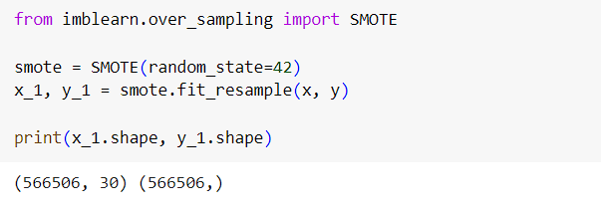

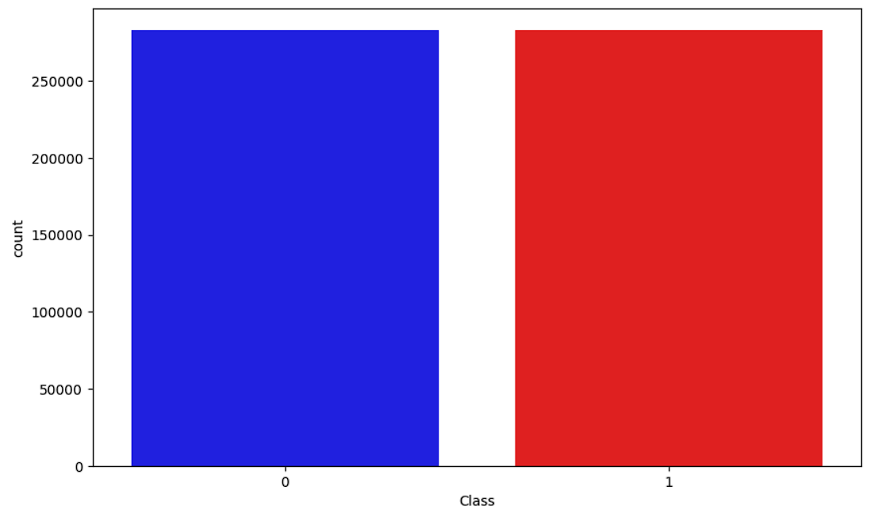

**Feature Selection & Engineering**

Selecting relevant features is crucial for model accuracy. Irrelevant features can introduce noise and reduce model performance. This step involves identifying and keeping only those features that contribute meaningfully to predicting fraud.

**Feature Engineering:** Creating new features that capture underlying patterns in the data can enhance model accuracy. For example, time-based features might capture fraudulent activities at specific times of the day.

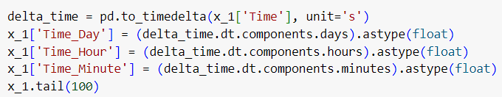

By Experimenting with different Time features and their impact on the model's performance below features are dropped

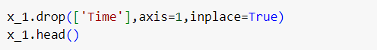

Identify relevant features for the model and drop irrelevant features. Normalize the numerical features.

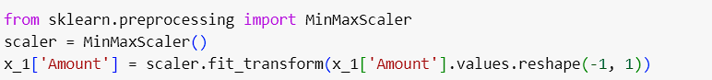

**Model Building**

**Choosing Logistic Regression:** Logistic Regression is selected as the classification algorithm due to its simplicity and effectiveness in binary classification problems like fraud detection. It models the probability that a given input point belongs to a particular class.

**Import Necessary Libraries**

**Importing Libraries:** Before proceeding, necessary libraries such as LogisticRegression from sklearn.linear_model are imported. This ensures that all the tools required for model building and evaluation are available.

**Understand Logistic Regression**

**Overview of the Algorithm:** Logistic Regression estimates the probability of a binary outcome (fraud or no fraud) by fitting data to a logistic curve. It is crucial to understand its parameters, such as the regularization term, for effective model configuration.

**Model Training**

**Training the Model:** The training process involves using the fit method to learn from the training data. This step is critical as it allows the model to understand patterns in the data that distinguish fraudulent from non-fraudulent transactions.

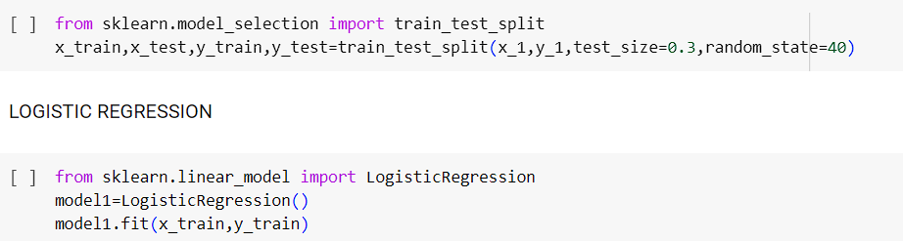

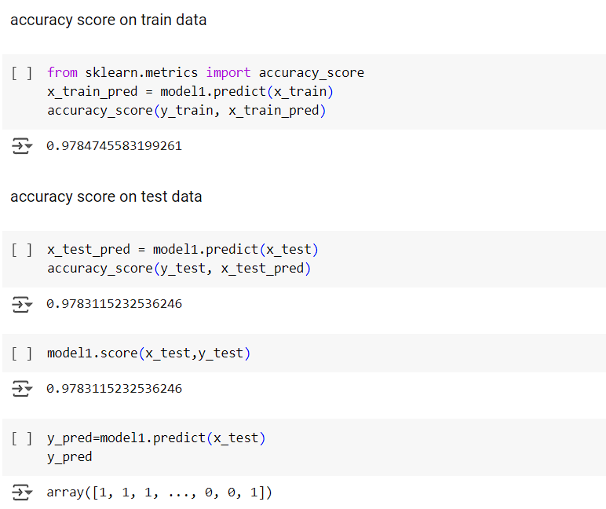

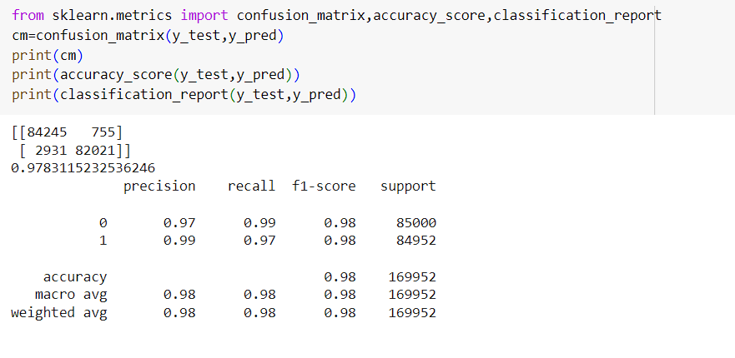

**XGBoost**

**XGBoost**is an optimized distributed gradient boosting library designed to be highly efficient, flexible, and portable. It implements machine learning algorithms under the [Gradient Boosting](https://en.wikipedia.org/wiki/Gradient_boosting) framework.

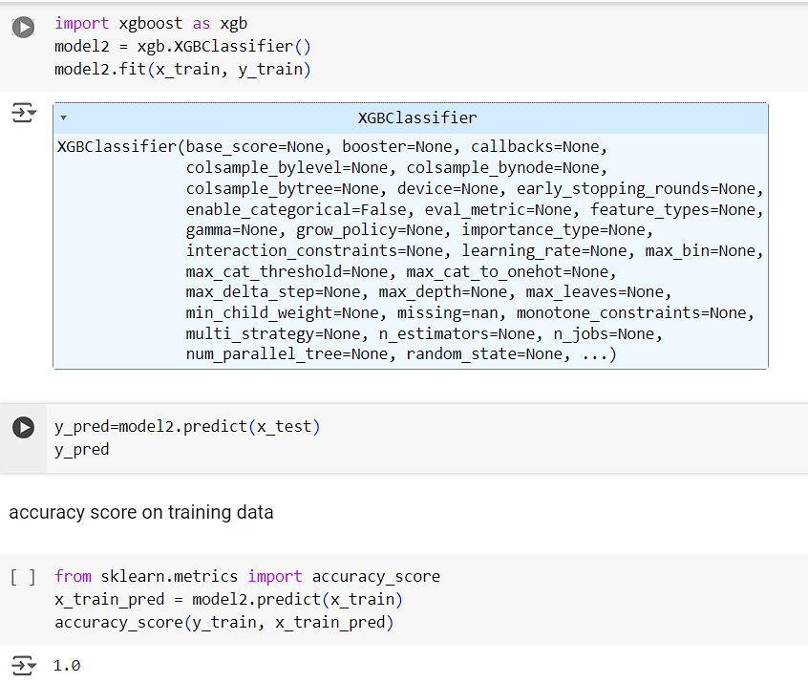

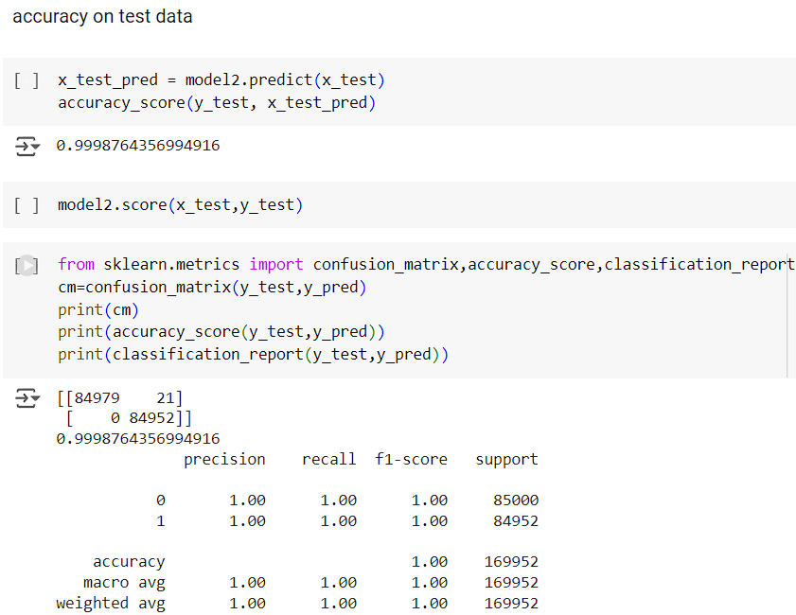

**Model Tuning**

**Hyperparameter Tuning**

Using **GridSearchCV or RandomizedSearchCV:** These techniques automate the process of hyperparameter tuning by testing different combinations of hyperparameters and selecting the best-performing model.

**Import Necessary Libraries**

**Importing Libraries:** Libraries such as GridSearchCV and RandomizedSearchCV from sklearn.model_selection are imported to facilitate hyperparameter tuning.



**Creating a Hyperparameter Grid:**This involves defining the hyperparameters to be tuned, such as the regularization strength for Logistic Regression, and their respective ranges.

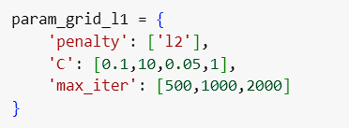 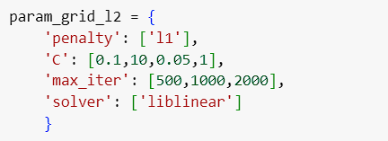

**RandomizedSearchCV**

**RandomizedSearchCV – Penalty:L2**

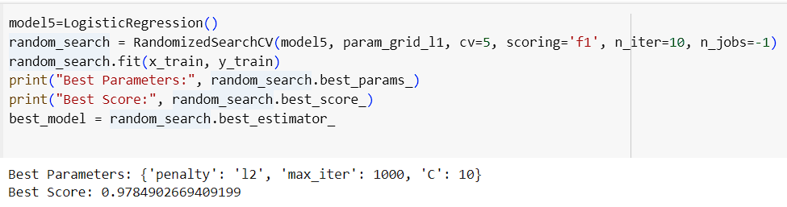

**RandomizedSearchCV – Penalty:L1**

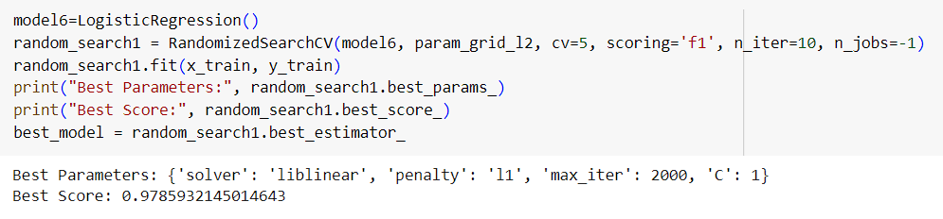

**Model Evaluation**

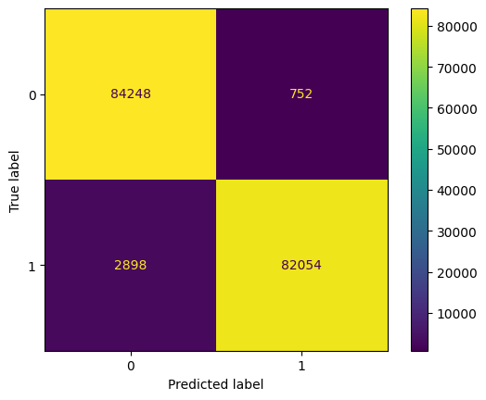**Logistic Regression** : Below is the Confusion Matrix and ROC-AUC curve for Logistic Regression.

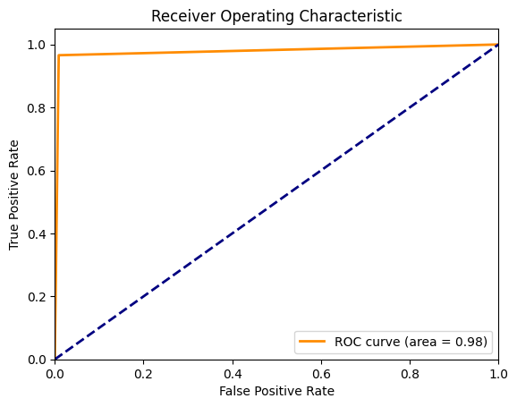

# 

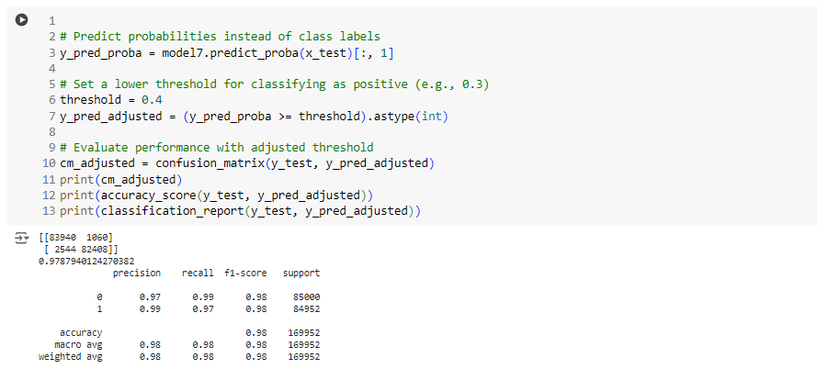

**XGBoost:** : Below is the Confusion Matrix and ROC-AUC curve for XGBoost.

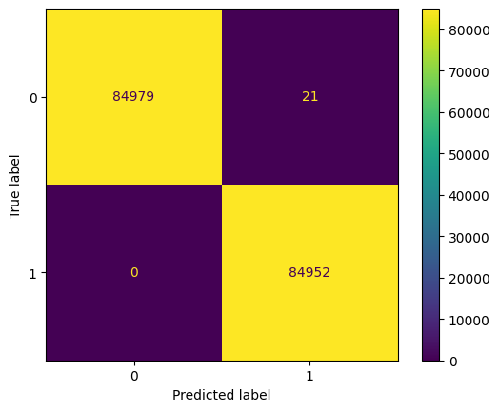

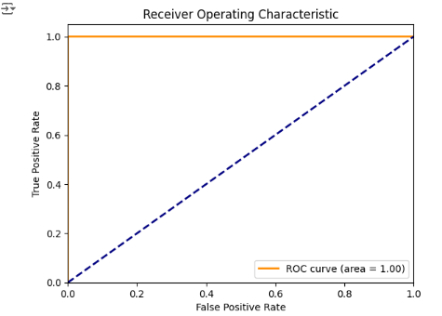

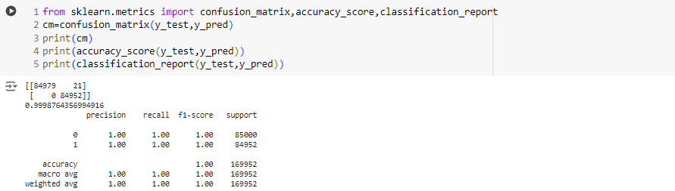

**References**

1]. Aleskerov, Emin & Freisleben, Bernd & Rao, Bharat. (1997). CARDWATCH: A neural network-based database mining system for credit card fraud detection. IEEE/IAFE Conference on Computational Intelligence for Financial Engineering, Proceedings (CIFEr). 220 - 226. 10.1109/CIFER.1997.618940.

2]. Samaneh Sorournejad, Zahra Zojaji, Reza Ebrahimi Atani, Amir Hassan Monadjemi, A Survey of credit card fraud detection techniques: Data and techniques-oriented perspective.

3]. Yashvi Jain, Namrata Tiwari, Shripriya Dubey, Sarika Jain, A Comparative Analysis of Various Credit Card Fraud Detection Techniques, Blue Eyes Intelligence Engineering and Sciences Publications 2019

**Conclusion**

From the above model it was observed that  
1. While using Smote Oversampling Technique with Logistic Regression model is giving recall **0.97** for fraud class and **0.99** for normal class with accuracy **0.9791**.  
2. After hyperparameter tuning model is giving recall **0.97** for fraud class and **0.99** for normal class with accuracy **0.9793**, which is slightly better.  
3. On the other side after using XGBoost model is giving recall and f1 score for both normal and fraud class was 1 with accuracy **0.9998**. Hence it is concluded that XGBoost model is the best in Credit Card Fraud Detection.

**Future Scope**

# 

There is always space for improvement in a project like this. Owing to the sensitivity of this project, different techniques can be integrated as components and their results combined to increase the quality of the final output. This model can be improved even further by adding more algorithms. These algorithms' result, however, must be from the same structure as most of the others. The modules are simple to add once that criteria are met, as seen in the script. Its is beneficial. As a result, we can employ a range of ways to address this issue in the project's ongoing growth.